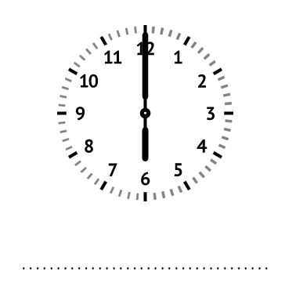

**Kloklezen**

……………………………………….

……………………………………….

……………………………………….

Dagelijkse (reken)kost : extra uitdaging

**Tafelrijtjes**

|  |  |
| --- | --- |
| 9 x 2 = ……. | 16 : 2 = ……. |
|  |  |
| 3 x 10 = ……. | 10 : 5 = ……. |
|  |  |
| 7 x 5 = ……. | 80 : 10 = ……. |

|  |
| --- |
| ***Optellen en aftrekken tot 100 ZONDER brug.*** |
| 40 + 20 = ………….…………………….………… |
| 30 + 20 = ………….…………………….………… |
| 80 - 60 = ………….…………………….…………  80 - 60 = ………….…………………….………… |
| ***Optellen en aftrekken MET brug.*** |
| 37 + 4 = |

91 – 6 =

**Teken met kleurpotloden het weer van vandaag.**

**Meetkunde 2D – Vul de juiste naam in.**

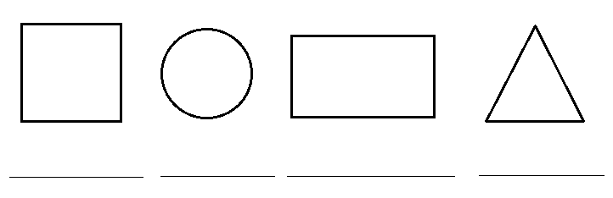

Dagelijkse (reken)kost

**Tafelrijtjes**

|  |  |
| --- | --- |
| 3 x 2 = ……. | 30 : 10 = …… |
| 5 x 0 = ……. | 20 : 5 = …… |
| 9 x 10 = ……. | 12 : 2 = …… |
| 2 x 5 = ……. | 3 : 1 = …… |
| 7 x 1 = ……. | 18 : 2 = …… |

|  |  |
| --- | --- |
| ***Optellen en aftrekken tot 100* ZONDER brug.** | |
| 23 + 32 = ………….…………………….…………………….… | |
| 14 + 51 = ………….…………………….…………………….… | |
| 24 + 34 = ………….…………………….…………………….… | |
| 64 – 22 = ………….…………………….…………………….… | |
| 88 – 65 = ………….…………………….…………………….… | |
| 84 – 81 = ………….…………………….…………………….… | |
| ***Optellen en aftrekken met brug***  36 + 7 = …………………  23 + 8 = …………………  34 - 6 = …………………. | |
|  |
|  |

**Teken met kleurpotloden je lievelingsdier.**

**Teken je toekomstige wagen.**

**Tafelrijtjes**

|  |  |
| --- | --- |
| 5 x 2 = ……. | 18 : 2 = ……. |
| 8 x 5 = ……. | 10 : 10 = ……. |
| 1 x 7 = ……. | 12 : 2 = ……. |
| 3 x 10 = ……. | 35 : 5 = ……. |
| 9 x 5 = ……. | 70 : 10 = ……. |

|  |
| --- |
| ***Optellen en aftrekken tot 100* ZONDER brug.** |
| 54 + 13 =………….…………………….………………….……………….. |
| 62 + 17 = ………….…………………….……………….……………….. |
| 22 + 71 =………….…………………….……………….……………….. |
| 87 – 15 = ………….…………………….……………….……………….. |
| 69 – 68 = ………….…………………….……………….……………….. |
| 48 – 34 = ………….…………………….……………….……………….. |
| ***Optellen en aftrekken met brug*** |

37 + 5 =

82 – 5 =